**Spanish police investigate deaths of four migrants forced off speedboat**

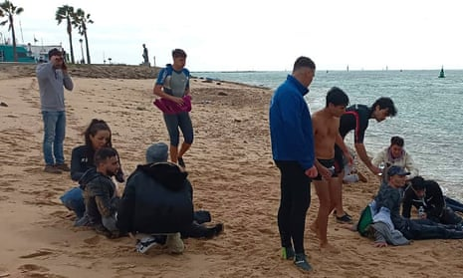

Spanish police have opened an inquiry after four people were killed as a result of being forced out of a moving speedboat into the sea just metres from the southern shores of Andalucía.

The people who died on Wednesday were among 27 passengers apparently forced off the fast-moving vessel by its drivers near Camposoto beach in the province of Cádiz, officials said. Another eight were left near Sancti Petri beach. All 35 people were believed to be migrants from northern [Africa](https://www.theguardian.com/world/africa), the Spanish government press office said.

The rest of the passengers forced off the boat, including six children, survived. Four people were taken to hospital, some with hypothermia.

Images on social media appeared to show a black vessel near a beach as people were being pushed off the side of the boat. A handful of others were already in the cold, choppy waters, struggling to stay afloat.

The incident comes months after an internal report by Frontex, the EU border and coast guard agency, said smugglers were increasingly using speedboats to transport migrants from [Morocco](https://www.theguardian.com/world/morocco) to Spain.

Often when they neared the shores of Europe, the drivers used violence to hurriedly throw or force migrants off the boats, turning back quickly to avoid being intercepted by police, the [newspaper El País reported](https://elpais.com/espana/2023-11-29/mueren-cuatro-inmigrantes-en-cadiz-tras-ser-arrojados-al-mar-desde-una-narcolancha.html).

Javier González, who manages a company offering windsurfing lessons, told reporters: “We saw a drug trafficking boat arriving but they weren’t trafficking drugs but migrants. Suddenly, they began jumping and some were thrown.”

González and his son rescued eight people, he said. “One of them told us that they put a gun to him and told him that either he jumped or they would shoot him.” González and his son made two trips to pull people from the water.

“They were all young, between 15 and 20 years old. Those who were able to talk thanked us,” he said. “You can’t imagine their faces, they were terrified. They said they had paid €5,000 (£4,300) for this trip.”